
Masako Miki: “Ancient Demons march in Kawaii cuteness at MAAM: A conversation with Lisa Tung”
By Joanna Metodieva
February 9, 2026

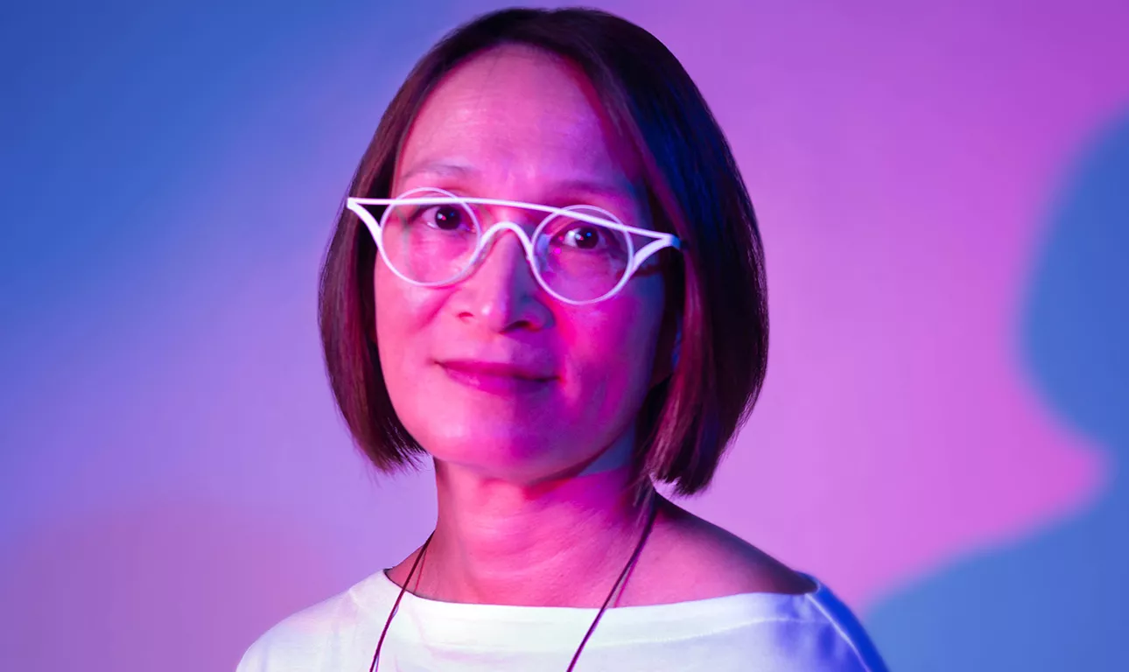

A Museum Without a Collection Leans Into Myth and Experimentation, Turning a Boston Gallery Into a Cosmic Stage for Contemporary Yōkai

The MassArt Art Museum (MAAM) has long been a “cultural laboratory” for Boston with no permanent collection and the freedom to be experimental. Their latest exhibition, Midnight March, transforms the Stephen D. Paine Gallery into a “galaxy void”—a dark indigo universe where the supernatural beings of artist Masako Miki gather.

In this exclusive Q&A, MAAM Executive Director Lisa Tung discusses the evolution of Miki’s work from 2D watercolors to massive, “huggable” 3D felted sculptures inspired by Japanese tradition ‘yōkai’, and how these ancient Japanese myths are being updated for a digital, contemporary age.
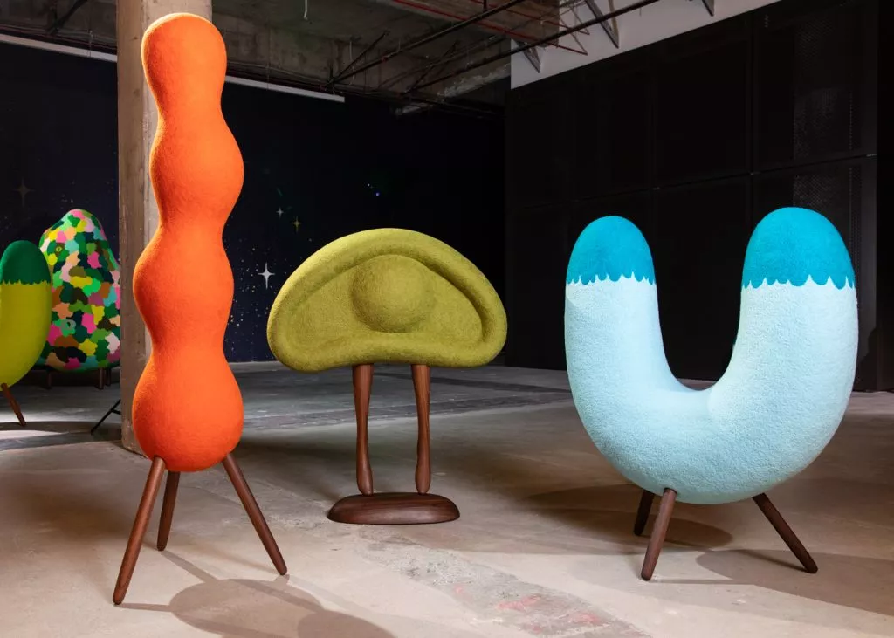

Masako Miki: Midnight March. Installation view: Institute of Contemporary Art San Francisco. Photo: Nicholas Lea Bruno.

Joanna Metodieva: Lisa, you’ve mentioned that your goal at MAAM is to bring in shows that highlight professional artists working across vast areas of study—from textiles to sculpture. What was it about Masako Miki’s Midnight Marchthat first caught your eye during your research?

Lisa Tung: I had been a fan of Masako’s earlier work, which was mainly two-dimensional paintings and watercolors. Then, I attended an exhibition called Bay Area Now, and I was very surprised and happy to see that Masako had an installation that featured the beginnings of this three-dimensional work. They were these very colorful, very approachable shapes—you wanted to hug them. I thought, “What is this?” What drew me to them was this approachability and accessibility, which are two of the things that the MassArt Art Museum really tries to do.

Joanna Metodieva: The scale of these works is quite immersive. How does the unique architecture of MAAM enhance the experience of this “march”?

Lisa: We are in an old 1906 building with terracotta vaulting and ceilings that go up 37 feet. It’s a very airy, spacious gallery. In our installation, we have covered all the walls and the floor with this really beautiful covering inspired by Masako’s paintings of a galaxy.
Then, she’s put all her sculptures inside this “fish tank”. The viewers, in addition to walking amongst all the sculptures as part of the march, can also go up our viewing balcony 18 feet above the floor. When they look down, it’s as if they are another entity looking into a microcosmic world. You really are stepping into your own world.

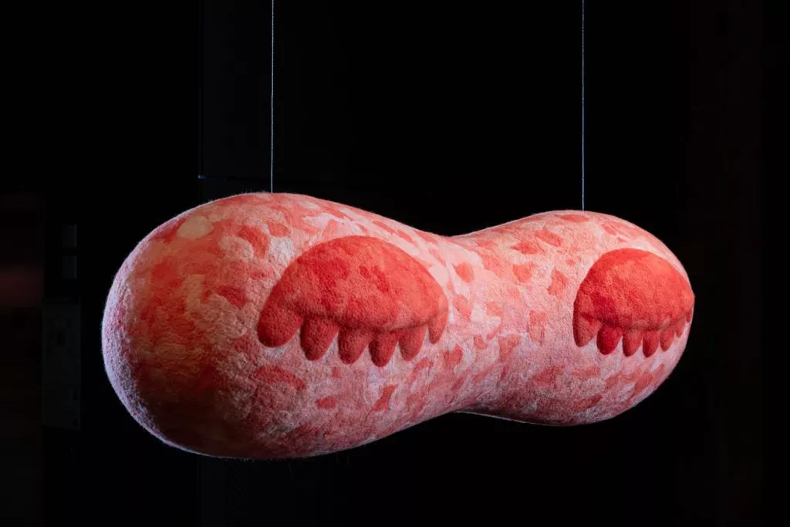

Masako Miki: Midnight March. Installation view: Institute of Contemporary Art San Francisco. Photo: Nicholas Lea Bruno.

Joanna Metodieva: These sculptures are based on yōkai—traditionally terrifying monsters from folklore. Can you talk about the specific characters visitors will encounter and the more traditional stories behind them?

Lisa: The characters range from tree-like forms to an inanimate object like an umbrella. In Japanese yōkai lore, the umbrella is something that is used a lot by humans and therefore can have its own magical qualities that come to life. These characters often stem from the Hyakki Yagyō, or the “Night Parade of One Hundred Demons,” a tradition where supernatural beings march through the streets at night. Masako’s newer work has human-like legs now; she also has an eyeball on human legs to represent heightened awareness and liveliness. Then she has animals, such as a cat and a fox. In Japanese iconography, a fox sometimes symbolizes a seductive woman; they are intelligent and they are magical. The “cat with two tails” found here is also a more powerful and mysterious figure in traditional lore.

Joanna Metodieva: It is fascinating how Masako’s sculptures re-envision these traditionally terrifying yōkai. There seems to be a direct lineage between these ancient spirits and the modern ‘kawaii’ culture we see today—how do you see that connection manifesting in this show?

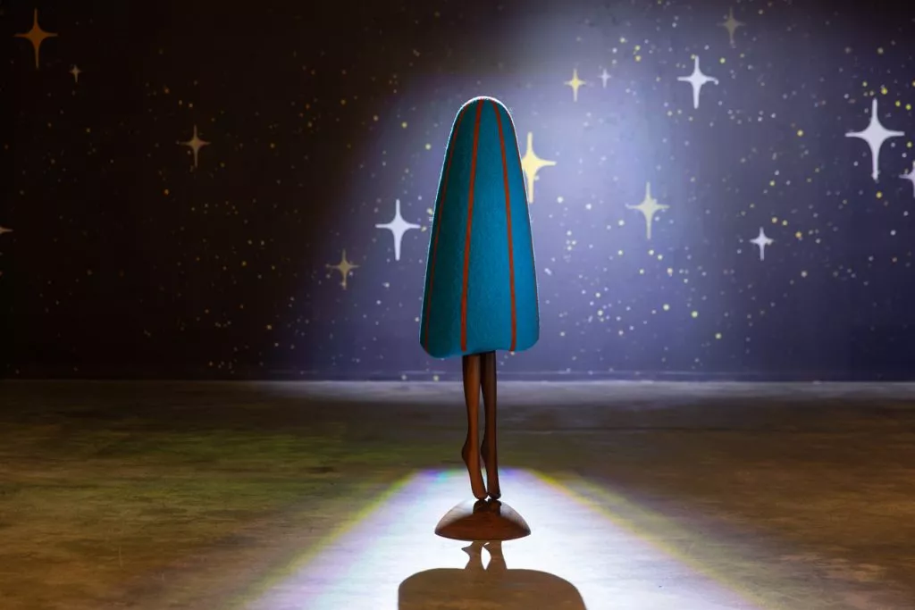

Masako Miki. Umbrella’s Whispers, 2025. Collection Dear Kala Trust. Photo: Nicholas Lea Bruno.

Lisa: Absolutely. It’s almost like a lot of Japanese culture—the things that we are drawn to, the cuteness, the kawaii—all do stem somewhat from yōkai. The yōkai is just this imaginary creature, and then the Japanese, being so adept with animation and anime and manga, they then change that into Pokémon, into Tamagotchi toys. Our colleagues at the MFA linked this even to the Marie Kondo book about how to de-clutter. She proposes picking up every object, and if it gives you joy, you keep it, but before discarding it, you say “thank you” to the object. This is tapping into this Shinto belief that there are spirits in inanimate things.
Joanna Metodieva: Why do you think Masako’s decision to “update our myths” is so important for a contemporary audience?
Lisa: One of Masako’s MOs is to try to create new inclusive narratives that seek to bridge cultural divides. The yōkai, this parade of a hundred demons, could have been a cautionary tale warning people, “Hey, don’t go out at night, it’s dangerous”. So, they made up a story to keep people inside. Now, we are less community-focused; we rely a lot on technology and AI. Masako is taking this historic folklore and turning it into something very approachable. The more you learn about something, the more it is part of all of us. It promotes togetherness.
Visit MAAM Boston to experience the vibrant world of Masako Miki’s Midnight March.
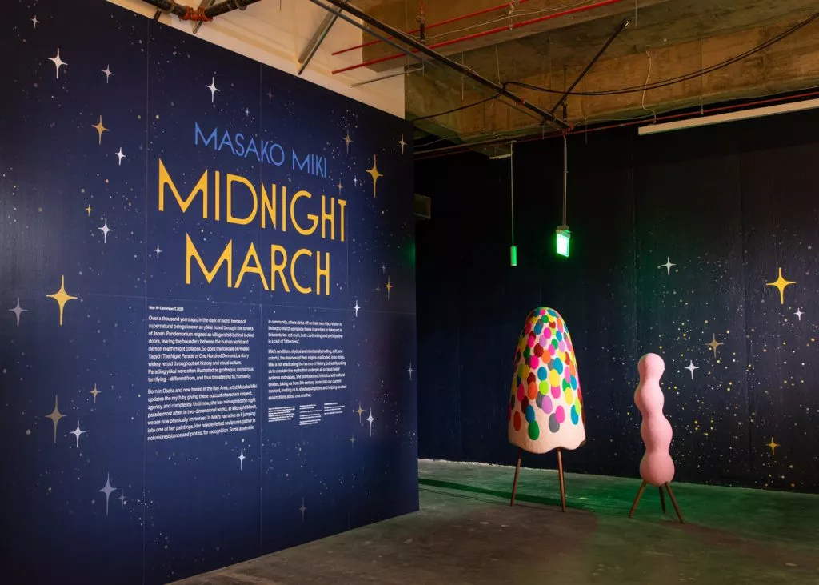

Masako Miki: Midnight March. Installation
view: Institute of Contemporary Art San
Francisco. Photo: Nicholas Lea Bruno.

Visit MAAM Boston to experience the vibrant world of Masako Miki’s Midnight March.

