
Sadie Barnette: “Creative Capital announces 2026 awardees and new “state of the art” grant”
By Maxwell Rabb
January 9, 2026

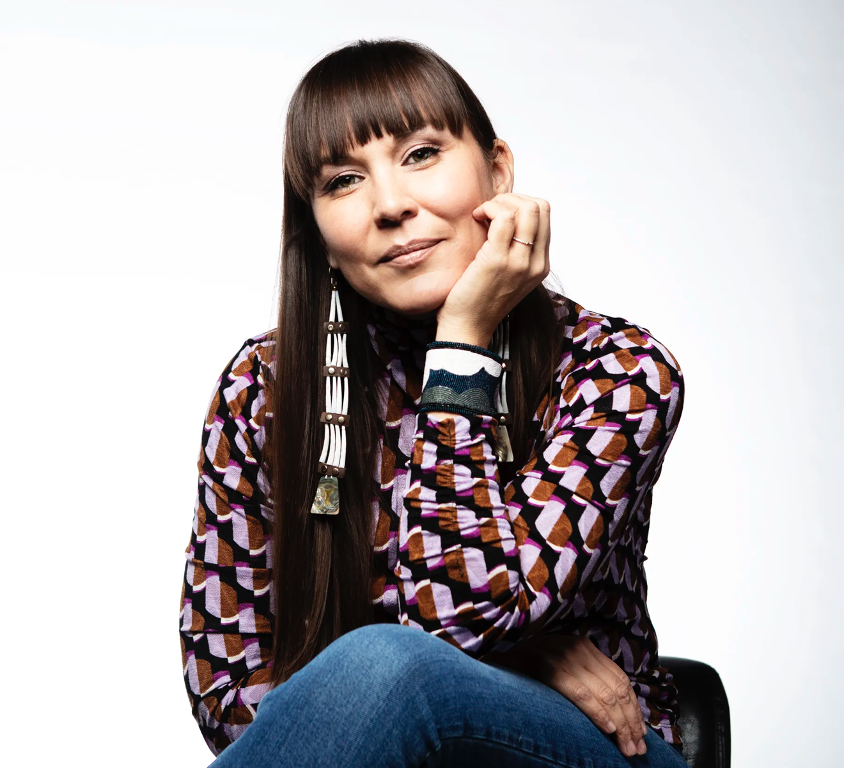

Portrait of Cara Romero. Courtesy of Creative Capital

Creative Capital has announced that it will distribute $2.9 million in grants to 109 artists across all 50 states as well as U.S. territories, marking one of the largest funding commitments in the nonprofit’s 25-year history.

The 2026 awards include the long-running Creative Capital Award—supporting 49 new projects across disciplines—and the inaugural “State of the Art Prize,” a new national initiative offering $10,000 unrestricted grants to 53 artists. This prize was awarded to one artist in every state as well as Washington, D.C., Puerto Rico, and Guam. The winners work across visual arts, literature, performing arts, and film.

The Creative Capital Award provides $50,000 in unrestricted project grants to “risk-taking” artists. These artists will receive professional development and mentorship services. This year, the recipients of both prizes were chosen from 4,546 applicants from all 50 states.

“The 2026 Creative Capital Awarded projects boldly push artistic form and ideas forward, from an Arabic-language jazz opera; to a family-owned grocery store transformed into a community space in gentrifying Washington, D.C., to a film meditation on the color blue,” Angela Mattox, director of artist initiatives at Creative Capital, said in a statement.

The nonprofit framed the awards as especially urgent as U.S. cultural policy continues to constrict funding and institutional support for the arts. “In this moment of urgent and widespread need for arts funding, generous supporters have helped Creative Capital expand our open call, national grant program to serve innovative artists in all 50 states,” said Christine Kuan, president and executive director at Creative Capital.

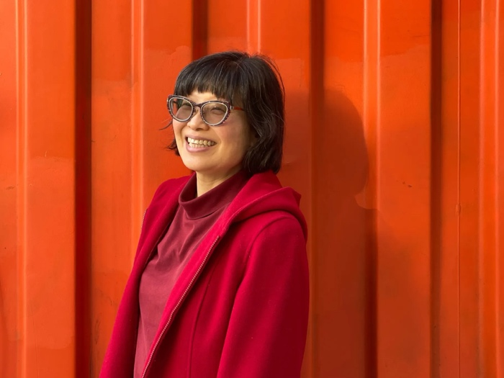

Portrait of Yoshie Sakai by Muzi Li Rowe. Courtesy of Creative Capital.

Here are the winners of the 2026 Creative Capital Award in visual arts:
- Sadie Barnette
- Gina Beavers
- Kenturah Davis
- Liss LaFleur
- Pepe Mar
- Masud Olufani
- Jeff Ostergren
- Margaret Pearce
- Ronald Rael
- Cara Romero
- Yoshie Sakai
- Jean Shin
- Catherine Telford Keogh
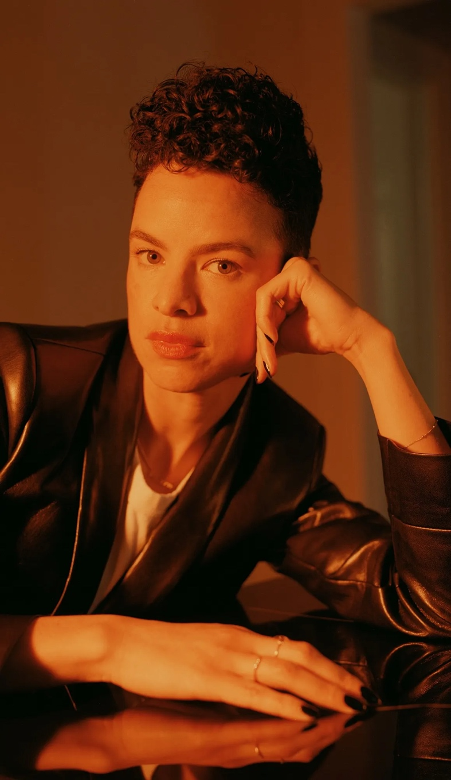

Portrait of Sadie Barnette by Damien Maloney. Courtesy of Creative Capital.

Here are the recipients of the inaugural State of the Art Prize in visual arts:

- Katie Baldwin Basile
- Karen Brummund
- Danielle Hatch
- brooke smiley
- Yumi Janairo Roth
- B Proud
- Nydia Blas
- Lorenzo Triburgo
- Kate Greene
- Ash Arder
- Rosy Simas
- Coulter Fussell
- Jazsalyn
- Elle Billing
- Hannah Demma
- Aspen Golann
- Dahlia Elsayed
- Brad Rose
- Juniper Harrower
- Ayumi Ishii
- Elisheba Israel Mrozik
- Russel Albert Daniels
- Ali Printz
- Conor Mullen
- Javier Orfon
- Njena Surae Jarvis

