Matthew Angelo Harrison: Future Perfect
Written by Kim Beil
May 17, 2019

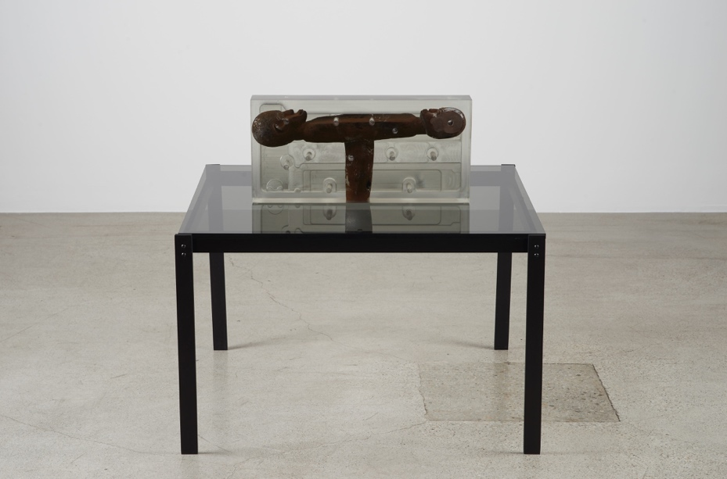
Dark Silhouette: Seated, 2018. Wooden sculpture from West Africa, polyurethane resin, anodized aluminum, and acrylic, sculpture: 9.625 x 20.375 x 3.125 in., overall: 29.625 x 32 x 32 in. Photo: Courtesy the artist and Jessica Silverman Gallery, San Francisco

Matthew Angelo Harrison met me at Stanford University’s Automotive Innovation Facility on a brisk day in February. Surrounded by oak trees on the edge of campus, the building is clad in green corrugated metal. Inside, it is a bright, clean space with six garage bays; it looks more like a lab than a body shop. Harrison quickly seemed at home. By the time I arrived, he’d already met the engineers, and they introduced him to that familiar centerpiece of labs and tech startups alike: the espresso machine. Harrison worked for three years in Product Development at Ford Motor Company in his hometown of Detroit, after completing his BFA at the School of the Art Institute of Chicago. He landed the job despite having no formal training in clay modeling. As with many of the techniques that are now pivotal to his sculptural work, he tells me that he learned the practice from YouTube videos. Even now, when he has more experience, he strives to re-create the feeling of ingenuity born of necessity. “All of my training is informal,” he says. “It’s very important how you arrive at discovering something. The journey is what shapes the aesthetic. Sometimes it’s better to be less efficient. The time you spend is going to give you a more interesting result.”

The processes and visual language of industrial design and advanced machining are crucial to Harrison’s work, which has been the subject of solo museum exhibitions at the Museum of Contemporary Art, Detroit, and the Broad Museum at Michigan State University. In 2018, his work was included in the New Museum Triennial, and it is currently featured in the Whitney Biennial. The beginning of Harrison’s rapid rise overlapped with his time at Ford. He recalls, with a sense of wonder at his youthful ambition, that he’d finish a long shift at Ford, then go directly home to his mother’s basement where he was building his own 3D printer. He says, “I lived at home, with my mom, because I took all the money I made at Ford and spent it on aluminum motors, stepper motors, and sensors. I was really sacrificing everything to do this, instead of just making paintings.” He learned from open-source projects online and from industry insiders, such as paste dispensers in the food industry or concrete suppliers, whom he would call ostensibly on business for Ford.

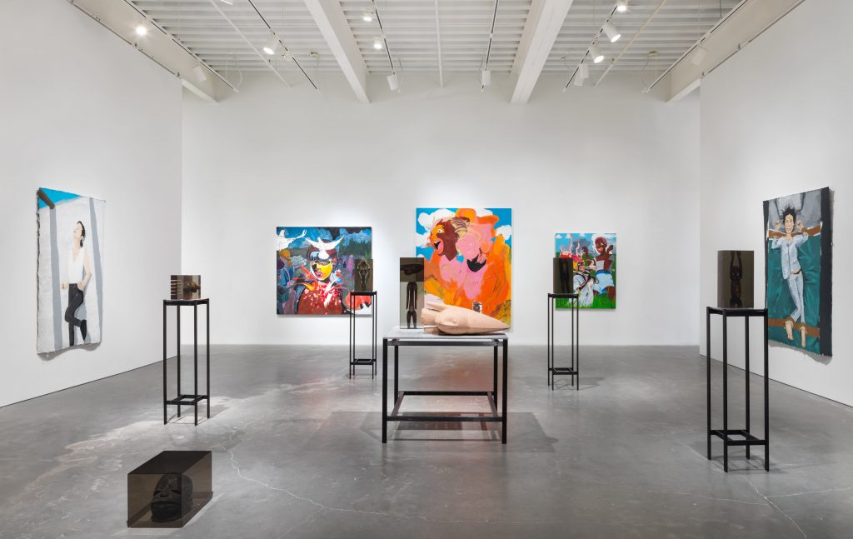
Exhibition view of “Songs for Sabotage,” 2018. New Museum Triennial, New York. Photo: Maris Hutchinson/EPW Studio

Our tour at Stanford began with MARTY, a stainless steel-bodied DeLorean, like the time-traveling car in Back to the Future (which was released in 1985, four years before Harrison was born). Unlike the vehicle that took Michael J. Fox on a journey into the past as Marty McFly, however, this one is decidedly future-facing. MARTY is fully electric and autonomous, but it isn’t just a normal self-driving vehicle, either. It’s engineered to drift. Harrison, the car’s engineers, Tushar Goel and Jonathan Goh, and I crowded around a laptop to watch the latest video from the test track. Drone footage showed the car executing a precise choreography of doughnuts and figure 8s, gliding by traffic cones and hay bales at high speed in a rising cloud of white smoke. Instead of maintaining traction when cornering, drift drivers learn to control how a car can slide through a corner against the tread of the tires. The Stanford research is intended to test the limits of autonomous vehicles in order to create driving software that can maneuver around the most dangerous situations.

Goh convinced Harrison to sit in the driver’s seat. The gull-wing doors rose to reveal a tiny, sunken cockpit. Goel unscrewed the steering wheel so that Harrison could lower himself into the narrow racing seat. He admired the metal toggle switches that power on the car: “I really love mechanisms. That’s one thing I do as a hobby, I draw mechanisms.” The engineers grin; they’ve found a kindred spirit. Where a normal car would have a gearshift, the DeLorean has a flat metal console with silver switches and a cartoonishly large red button.

Like Fox’s fictional DeLorean, Harrison’s work is also a means of looking forward by looking back. As a clay modeler at Ford, he was part of a large team that transformed designers’ sketches into three-dimensional, full-scale models by molding hundreds of pounds of clay on top of precision-cut foam. Harrison was struck by the number of models, or prototypes, that were abandoned in the process of finalizing a design. Inspired by the philosopher Nelson Goodman’s theories of worldmaking, Harrison imagines that each of those unfinished designs might be the origin of its own world, entirely separate from the path taken. He describes these as “prototypical possibilities.” Pointing to my iPhone as evidence, he explained that the thousands of design decisions that went into this object have had a mass effect on our world today. But, he says, had any one of those choices been different, our lives, and indeed the world itself, would be different now. We are conditioned to type with our thumbs, to pinch or double-tap a bright image on a screen. We could equally have adopted other modes of interaction, no matter how natural this set of gestures has come to feel. Through his sculptural installations, Harrison works backwards to imagine other possibilities within the realm of culture, rather than technology.
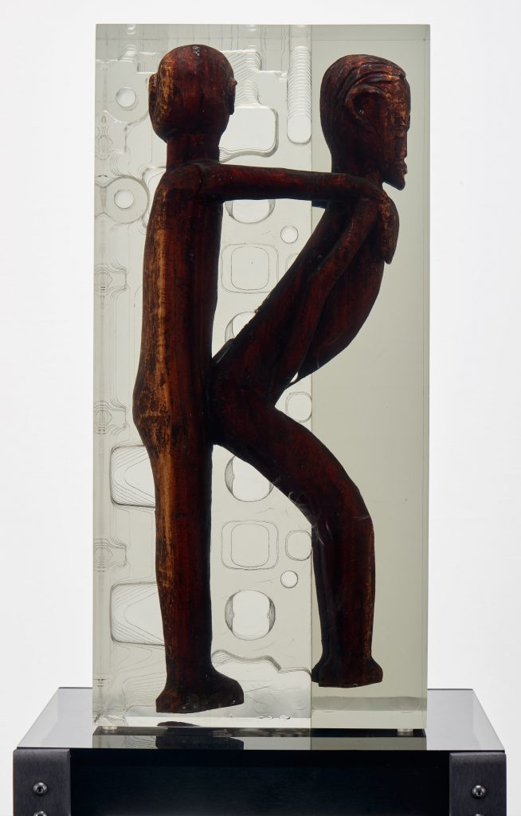
Dark Silhouette: Standing Couple, 2018. Wooden sculpture from West Africa, polyurethane resin, anodized aluminum, and acrylic, sculpture: 19.375 x 9.25 x 5.25 in., overall: 67.375 x 13 x 13 in. Photo: Courtesy the artist and Jessica Silverman Gallery, San Francisco

The possibility of alternate worlds was a focal point in Harrison’s solo show last spring at Jessica Silverman Gallery in San Francisco. “Prototype of Dark Silhouettes” included 12 works, which primarily featured traditional African sculptures made of wood, encased in translucent blocks of resin and mounted on thin metal legs. The figurative sculptures (whose specific cultural origins Harrison does not identify) are small, suited to standing on a tabletop or to being lifted with two hands. They mainly depict men and women, standing or seated on ceremonial stools, possessed with the confidence of self-presentation. Harrison sculpts the resin surrounding them using a computer numeric control (CNC) machine, which can cut complex shapes with absolute precision. Deep, circular cuts occasionally penetrate the gray-frosted resin, revealing the wooden sculpture at its core and evoking medical procedures, especially in light of the small pins and narrow rods of the bases. Other sculptures seem anthropological; the figures’ ritualistic poses appear frozen in resin, decontextualized and inscrutable under the bright lights of the white-walled gallery. Here, the resin reads as a vitrine and the minimal metal base, a pedestal. This interpretive plurality is important to Harrison. He recognizes that his work is “not always so legible and that’s intentional. That’s to allow the viewer to do some work. A lot of my work is about the viewer’s auto-response. Something might appear to be morbid, like when I’m cutting into an object.” He imitated an imaginary viewer holding out his hands in protest: “That feeling of ‘Wait, wait,’ is important. I’m interested in what I can provoke out of a viewer from what’s already there.”

Surrounded by clay models during the day at Ford, Harrison recognized that the concept of the prototype was also vital to his work. He tells me, “I started applying the idea of prototyping to more abstract things that didn’t have to do with commercial goods, like ethnicity or the effects of globalization on culture. Being African American and being freed up from the specifics of place, I don’t have direct lineage or a pedigree that extends to Africa. That’s totally severed. There are some elements that come through music or dance, but it’s not really clear; it’s murky.” Prototypes represent a way for Harrison to create possible pasts. He explains, “I can construct my own idea of what a homeland is. I can make that and see how that affects the world. It’s modular, too. I can change pieces of it.” Like the abandoned prototypes that Harrison recalls seeing around the design studio at Ford, each of these past models might have resulted in an alternate future.

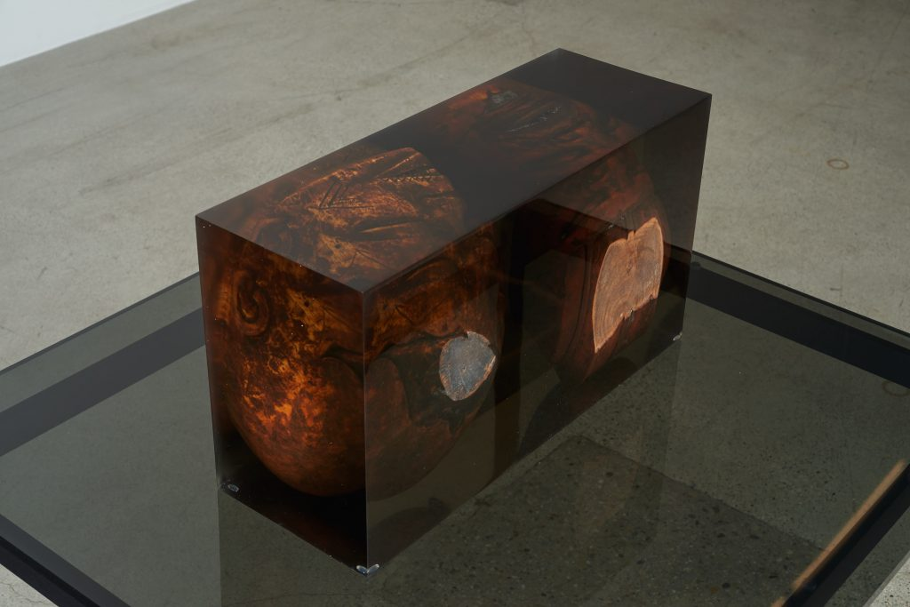
Dark Silhouette: Slanted Gaze, 2018. Wooden sculpture from West Africa, polyurethane resin, anodized aluminum, and acrylic, sculpture: 10.43 x 18.89 x 6.8 in., overall: 58.43 x 31.89 x 17.8 in. Photo: Courtesy the artist and Jessica Silverman Gallery, San Francisco

Harrison sources the wooden sculptures from the secondary market, buying mostly from European sellers on eBay. Drilling into the figures with the CNC machine to reveal the natural material beneath the plastic skin of resin, he also aims to highlight the multilayered process of exchange. The patterns that he cuts suggest a transfer or passage as well; they evoke the shapes of engine blocks, hydraulics, and transmissions, where potential energy is transformed into usable kinetic energy.

Reinserting himself as an African American artist into the equation of exchange also invokes the too-often-obscured history of black labor in the American economy. Many of Harrison’s family members have worked in the automotive industry. In the 3D-printed sculpture SBrwn_1x1x1 bkgd ; 1x1x1 bkgd (±0.1) (2017), he constrained the length of the printing material to reflect the distance between his studio in downtown Detroit and the factory where his mother once worked. The sculpture is inspired by the small black books made by Suriname-born, Netherlands-based conceptual artist Stanley Brouwn (1935–2017), which often chronicled the artist’s steps or listed walking distances from point to point. Harrison turns the sculptural form itself into a record of walking, allowing the extruded black ceramic to cross-hatch and pile on top of itself, as if the line made by walking could be picked up and gathered into one’s hands.

Like the anachronism of the clay model, Harrison’s process of building his own machines interrupts the expectations for contemporary automated production. He explains that typically the 3D printer is “used to create a representation of a rendering that was made on a computer, and it comes out perfectly. But if you get in between that, there are all these other beautiful possibilities. I like to work within a very rigid intention and kind of pry it open, letting the air out of that space.” SBrwn and other sculptures made using Harrison’s 3D printers also challenge the material perfection associated with minimal and conceptual art, revealing the many layered decisions of their makers, whether machine or human.

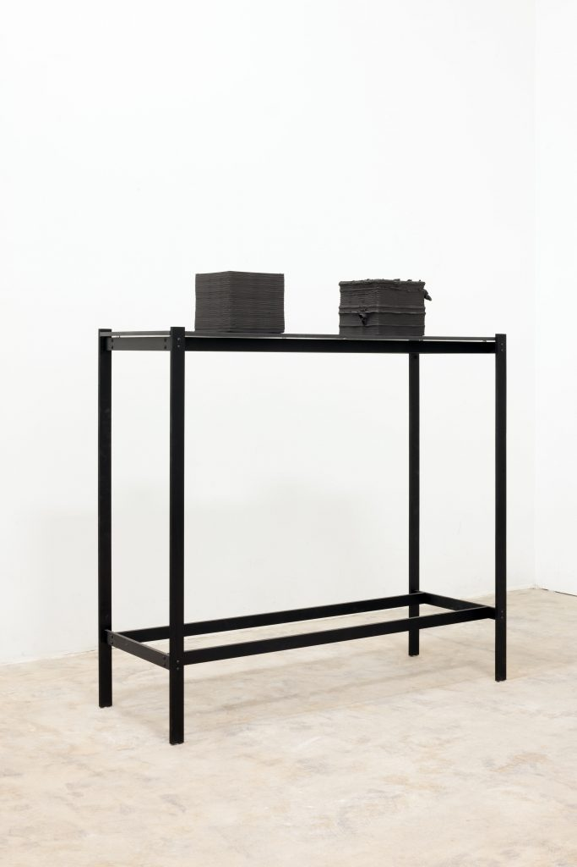
SBrwn_1x1x1 bkgd ; 1x1x1 bkgd (±0.1), 2017. 3D-printed ceramics, acrylic, and aluminum, 53 x 48 x 16.75 in. Photo: Courtesy the artist and Jessica Silverman Gallery, San Francisco

“Labor is the defining characteristic of how we identify with the world, here in the U.S.,” Harrison tells me. He is deeply concerned about the cultural implications of technological change and specifically with how artificial intelligence will shape the future of work. After viewing several autonomous vehicles during our afternoon at Stanford, he asked, rhetorically, “What will happen to identity and self worth when most jobs are replaced with robots?” He described a commercially made robot designed to produce wall drawings. “It’s not thinking but it’s rendering. So, what does that do to people who make murals? Or to people’s expectations for handmade murals? It flattens our world and makes it really boring. Pointing to the iPhone again, he said, “This machine is an extension of the developers and what they think about art. And that sucks.”

At the end of the tour, our small group crossed the garage to find two unremarkable-looking white cars. Compared to the DeLorean, with its futuristic shape and sheen, these were decidedly banal. But the future that they represent is, perhaps, even more radical because it will be pervasive. We stood next to a Ford Fusion equipped as an autonomous vehicle. The conversation turned to a recent study published by the Massachusetts Institute of Technology (MIT), which applied the philosophical thought experiment known as “the trolley problem” to self-driving cars. In the classic formulation, a runaway trolley is careening along a track: either you allow it to kill five people stuck on the tracks, or you push someone else into the trolley’s path, killing that person as a result, but saving the other five by stopping the trolley before it reaches them. The MIT experiment reimagined the problem with a self-driving car, which would, in one scenario, have to choose between hitting three elderly people crossing a street illegally or killing the three young people riding in the car. Millions of responses were gathered from people in more than 200 countries, revealing culturally specific ways of making these choices. As Goh described, “In a lot of the Western countries, people opted to run over the old people, because young people have more value than old people. But in the Asian countries, they tended to run over the young people because they revere elders.” Software engineers could choose to program autonomous vehicles differently according to these results, but, as the MIT authors suggested, they could also override such results and make choices that always privilege some scenarios over others. For Harrison, the point seems to be that in a world where self-driving cars exist, someone will have to make these devastating choices in advance. Much of his work rejects the rigidity and singularity of these kinds of decisions. Again, according to his study of Goodman’s philosophy, Harrison prefers to believe that many right answers may co-exist, even if they are in conflict.

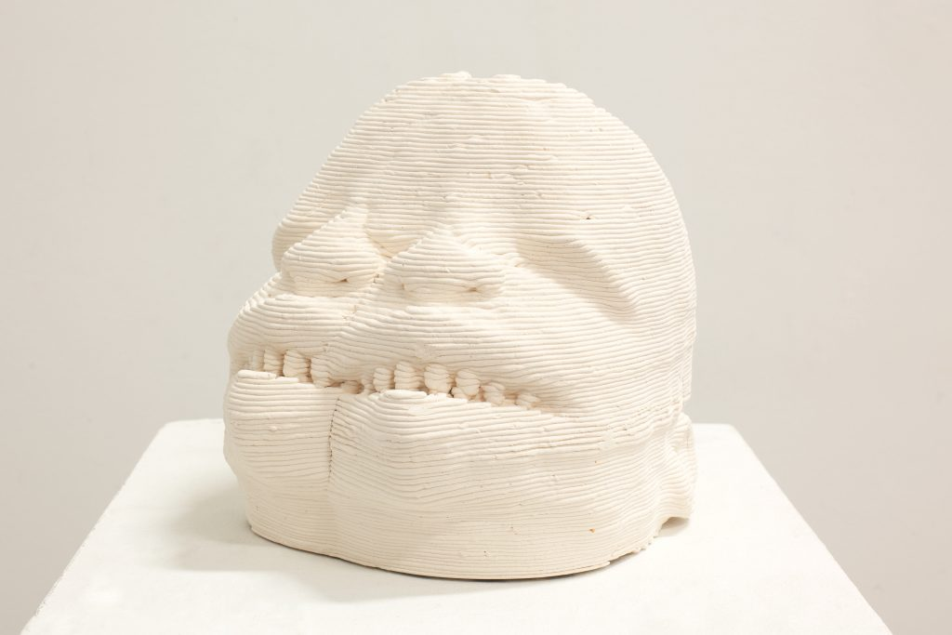
Mk-004-conjoined, 2017. Ceramic, acrylic, and aluminum, sculpture: 8.75 x 11 x 8.5 in. Photo: Courtesy the artist and Jessica Silverman Gallery, San Francisco

Harrison’s epistemology is thoroughly postmodern, exhibiting a preference for multiple, flexible, and forking paths, rather than hard-and-fast answers. He reconstructs a past that incorporates varied possibilities, an open worldmaking that allows us to imagine not only that tomorrow may be different but that today could be too, if only we embraced the multiplicity already inherent in the world. If only all the prototypes could go about their lives as products fully realized. Art, perhaps too often, privileges the unique experience. But, hidden beneath these singular objects are also multiples, often obscured by market forces: artist’s proofs, editions, copies. Multiplicity is a specter that haunts art just as it haunts the apparently identical objects furnished by factories and sold by Apple, IKEA, or the Ford Motor Company. Harrison’s work encourages viewers to reject these things as final and instead to imagine how the world might be different if only we could embrace the “prototypical possibilities.”

